|  |  |  |  |  |  |  |  |  |  |  |  |  |  |  |  |  |
| --- | --- | --- | --- | --- | --- | --- | --- | --- | --- | --- | --- | --- | --- | --- | --- | --- |
| Référence du document : | | | | KMN 00002 – A | | | | Référence client : | | | | AXMRSLU-UNIV2 | | | | |
| **Plan de cablâge reseau** | | | | | | | | | | | | | | | |
|  | | | | | | | | | | | | | | | |
|  | | | | | | | | | | | | | | | |
|  | | | | | | |  | |  | |
| **Résumé :** | | | | | | | | | | | | | | | |
| Ce cahier de spécification décrit l’ensemble du câblage réseau (BT et FO) | | | | | | | | | | | | | | | |
|  | **Elaboration :** | | | | | | | | | | | | |  | | | |
|  | |  | **Rédacteur** | | | **Vérificateur** | | | | | | **Approbateur** | | |
| **IND.** | | **DATE** | **NOM** | | **VISA** | **NOM** | | | | **VISA** | | **NOM** | **VISA** | |
| A | | 30/03/18 | P.MOYSE | |  | x | | | |  | | x |  | |
|  | **Historique :** | | | | | | | | | | | | |  | | | |
| **IND.** | | **DATE** | **REDACTEUR / MODIFICATIONS (ORIGINE, OBJET ...)** | | | | | | | | | | | |
| A1 | | 30/03/18 | Première diffusion | | | | | | | | | | | |
|  | |  |  | | | | | | | | | | | |
|  | |  |  | | | | | | | | | | | |
|  | |  |  | | | | | | | | | | | |
|  | |  |  | | | | | | | | | | | |

Contents

**No table of contents entries found.**

|  |  |
| --- | --- |
| **Terminologie** | **Définition** |
| BT | Basse tension (cuivre) |
| FO | Fibre Optique |

# FUTUR LOCAUX

## Présentation

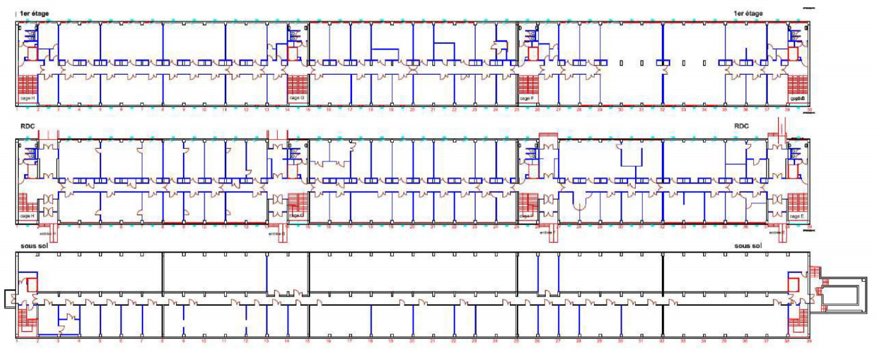

Figure n°1 : Plan physique des locaux